
Nano Sabz Gol Baharan
NO. | CAT NO | Name & Description | 5 gr |  | 10 gr | 25 gr | 50 gr |  | 100 gr
02-1 |  | Nanocomposites Powder
02-2 | NSG-NHA | Hydroxyapatite- Chitosan | * |  | * | * | * |  | *
402-3 | NSG-NHA | Hydroxyapatite- Collagen | * |  | * | * | * |  | * |  | 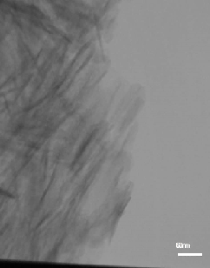
02-4 | NSG-NHA3 | Hydroxyapatite-gelatin | * |  | * | * | * |  | *
402-5 | NSG-NHA | Graphene Oxide reinforced Hydroxyapatite- | * |  | * | * | * |  | * |  | 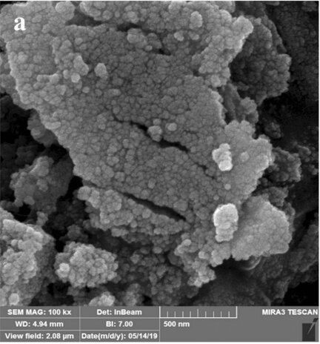
 |  | Nanopowders
402-1 | NSG-NHA | Pure NanoHydroxyapatite |  |  |  |  |  |  |  |  | 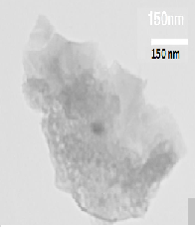
402-6 | NSG-NC | Natural Pure NaCl
402-7 | NSG-CP | TriCalcium phosphate | * |  | * | * | *
 |  | Calcium Hydrogen Posphate
402-8 | NSG-CA | Calcium Acetate | * |  | * | * | *
402-9 | NSG-NCO | NanoCalcium hydrOxide | * |  | * | * | *
402-10 | NSG-NCC | NanoCalcium Carbonate | * |  | * | * | * |  | *
402-11 | NSG-MA | Magnesium Acetate | * |  | * | *
402-12 | NSG-MO | Magnesium Oxide | * |  | * | *
402-13 | NSG-CIT | Chitosan | * |  | * | *
402-14 | NSG-BTCP | Tri Calcium phosphate | * |  | * | * | *
402-15 | NSG-NCU | Copper Nanoparticles | * |  | *
402-16 | NSG-NCO | Copper Oxide nanoparticle | * |  | * | * | *
402-17  402-18 | NSG-NZO  NSG-CNZO | Zinc Oxide Nanoparticles  Coated Zink Oxide | * |  | * | * | * |  | * |  | 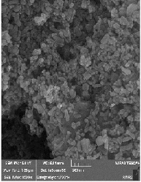
402-18 | NSG-NAg | Silver Nanoparticles | * |  | * | * | *
402-19 | NSG-GO | Graphene Oxide Np | *
402-20 | NSG-Gr | Graphene Nano sheets | *
Antibacterial Colloidal Solutions
402-21 | NSG-NCU-S | Concentrated Copper solution (ppm)
402-24 | NSG-NAg-S | Different Concentration of Silver solution ppm)
402-25 |  | Zink OXide  solution |  |  |  |  |  |  |  |  | 1.300.000
Colloidal solutions
 |  | Colloidal Hydroxyapatite solutions
Colloidal Graphene Oxide
solution
402-23 | NSG-GI | Glycerin Iodine |  | * | *
 |  | Colloidal Solutions
402-19 | NSG-PBS | Phosphate-Buffered Saline |  | * | * | * |  | * |  | *
402-20 | NSG-SBF | Simulated Body Fluid (SBF) |  | * | * | * |  | * |  | *
402-21 | NSG-LUT | Lutein Nanocapsuls |  | * | * | * |  | * |  | *
402-22 | NSG-NVIT-C | Natural Vitamin C |  | * | * | * |  | * |  | *
 |  | Paste
24 | NSG-NHA-P | Nano HydroxyApatite paste

